Importing Data From an External Source
- Download the Students text file and save it to your hard drive
- In the SQL Server Management Studio, right-click the Databases node and click New Database...
- Type ROSH and press Enter
- In the Object Explorer, right-click ROSH, position the mouse on Tasks and click Import Data
- On the first page of the wizard, click Next
- On the second page, click the arrow of the Data Source combo box and select Flat File Source
- On the right side of File Name, click the Browse button
- Locate and select the Students.txt file you had saved
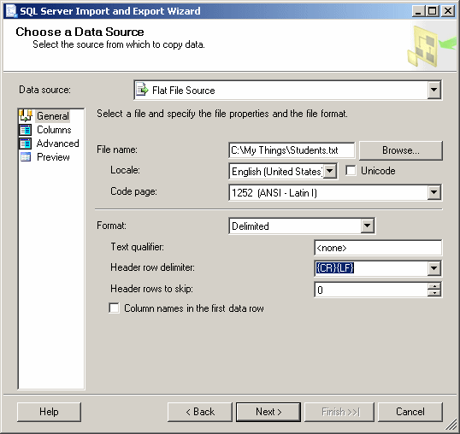
- Under Data Source, click Advanced
- As Column is selected, in the right list, click Name and type StudentID
- In the middle list, click each column and change its Name in the right column as follows:
Column | Name
Column0 | StudentID
Column1 | FirstName
Column2 | LastName
Column3 | DateOfBirth
Column4 | Gender
Column5 | Address
Column6 | City
Column7 | State
Column8 | ZIPCode
Column9 | HomePhone
Column10 | EmailAddress
Column11 | ParentsNames
Column12 | SPHome
Column13 | EmrgName
Column14 | EmrgPhone
- 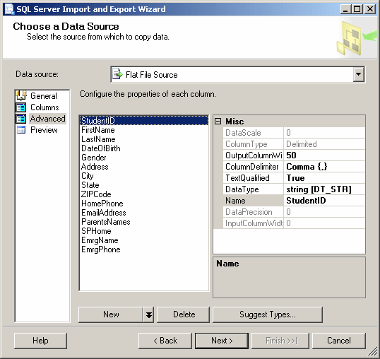
- To see the list of columns, under Data Source, click Columns
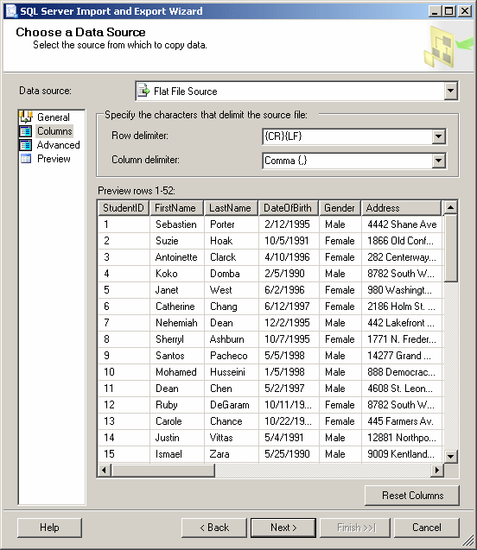
- Click Next 4 times
- Click Finish
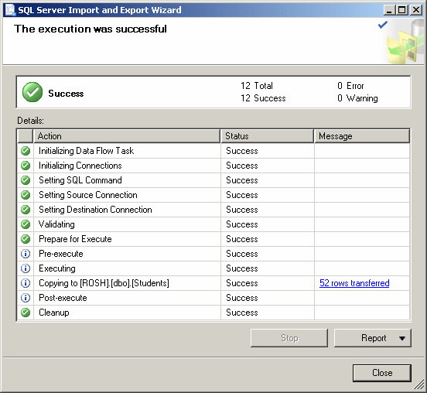
- Click Close
- Back in the Object Explorer, expand the ROSH and its Tables nodes.
Right-click Students and click Design
- As the StudentID field is selected, press Tab and change its data type to int
- Press F6 and expand Identity Specification. Double-click (Is Identity) to set its value to Yes
- Change the other columns as follows:
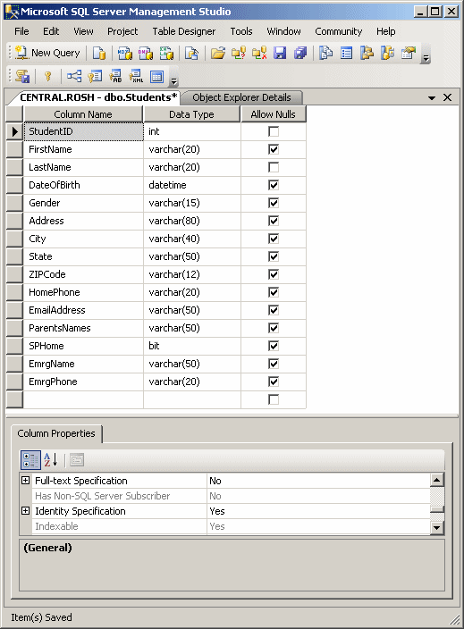
- To save the table, click the Save button on the Standard toolbar:
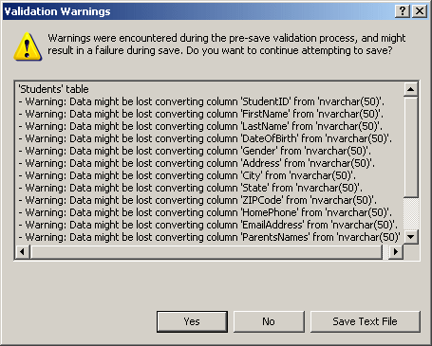
- When a Validation Warnings dialog box presents a few warnings, click Yes
- Close the table
- To view data stored on the table, in the Object Explorer, right-click dbo.Students and click Open Table

